

DRAFT FOR PLANNING STAGES ONLY

Strategic Marketing Plan Worksheet

V 0.3

Introduction

The purpose of this document is to capture and agree a sales and marketing plan which will essentially cover the pre and live beta period. The plan will be amended over time to cover post beta launch, extended sales strategies to continue to fuel subscriber growth via pre identified partners and other budget considerations.

The objective of this marketing plan is centered on four criteria:

- To create strong brand awareness of Next2friends Pre and during beta periods
- To maximize the traffic and number of visitors to next2friend.com
- To maximize the number subscriptions to next2friends.com.
- To maximize the conversion rate of subscribers to paying subscribers

Evaluation and Revision

Author | Version | Comment | Date
Fran | 0.1 | First draft | 10/11/07
Roy | 0.1 | Review | 11/11/07
Fran | 0.2 | Updated draft | 16/11/07
Roy | 0.3 | Updated draft | 17/11/07

Terminology

Acronym | Detail
TBD | To be Defined
TBA | To be Amended
REGS | Registrations
SN | Social Networks
Pre-beta | Period < 25/12/07
During-beta | Period 25/12 – 25/03/08
Live Production | Period > 25/03/08
Generation Y | ( 14-30 years age population)

Pre-Planning

Name and Role | Assigned Tasks
Fran, PMD | Coordinate strategic marketing planning process , Implementation and Budget request
Anthony, CTO | Initial approval , technical compliance & requirements
Andrew, COO | Economical signoff
Roy, CEO | Final approval
Fran, PMD | Implementation of the Plan

Pre Planning Timeline

Activity | Start Date | Target End Date
Determine key strategies & Implementation plan:  • What steps are needed  • What technologies must be in place  • What delivery methods will be used  • What marketing materials will be used  • When is it being implemented | 12/10/07 | 21/10/07
Complete Sign off Process | 12/10/07 | 18/10/07

Marketing Plan

Part 1: Marketing Objectives

A. Product Profile

Next2Friends is set to become one of the internets largest companies because it is a significant and incredibly important evolvement of Social Networking. Until now Social Networking has been primarily internet based. Next2Friends offers a revolutionary approach by enabling Social Networking on the world’s most ubiquitous technology – the mobile device. This is achieved by utilizing the Bluetooth stack of the device. Our software is downloaded and delivered to the user’s device as easily as a ring tone. The application of Social Networking using Bluetooth in this manner is a world leading approach and has already been protected by a patent application.

There are other incredibly compelling applications of this technology such as multiple live stream video over Bluetooth and polling over Bluetooth, WiFi or GPRS which we cover later in this Executive Summary. Our research indicated that our target market will eagerly adopt these applications, consolidating Next2Friends as the premier Mobile Social Networking Site. One of the key aspects of enabling Social Networking in mobile devices in this manner is that a user’s mobile device becomes a Self Propagating Intelligent Social Network (SPIN™). This is the perfect and seamless blend of Mobile and Internet technologies and will enable Next2Friends to capitalise upon and outperform proven successes such as YouTube, MySpace, Facebook, LinkedIn,Yowie and Zaiku etc.

B.Targets Audiences

N2F will address following audiences during our different phases:

Target Audiences | Needs of theirs that Next2friends can fulfill
Pre-beta : any audience to cover critical mass acquisition | - Users expectations and needs for a Mobile SN solution  - Frustrations with current SN solution providers
During-beta : any audience for continued acquisition and start to build loyalty with current subscribers | - User experience/usability/functional and UI needs  - Collaborative/sharing needs  - New features & feedback on existing ones
Live-Production : Generation Y-Segmented audience. | - User experience/usability/functional and UI needs  - Content related needs (collaboration, sharing, creation)  - New features & feedback on existing ones

Part 2: Market Focus

Our primary group would probably be the generation Y group defined on the following criteria;

Next2friends Target Market
 | Characteristics
Region | World wide
Target Market Size | >500M potential users in 2010
Density | Urban, suburban
Age | 14-30 years old (teenagers, studying age and young adults)
Gender | Male and Female
Annual Income | All under £25,000 ( $50,000)
Occupation | Students; new graduated; new workers; young professionals
Education | Elementary school, High school, University
Race | All
Home Ownership | Renting apartment/condo, living with parents
Personality | Brand conscious, anchored in popular culture, inclined for differentiation and sophistication, very tolerant towards multiculturalism and internationalism (open-minded), quick maturation with modern products
Lifestyle | Most of them dependent on parents, no major responsibilities, highly influenced by peer groups, active life, importance of school, work and social life
Internet Usage Rate | daily basis
User Status | Regular user
Loyalty Probability | Medium

Part 3. Key Objectives of Marketing Plan

Tangible and quantifiable objectives have been introduced and will be monitor pre, during and post beta launch. Measurement and monitoring of these key metrics is discussed at section E. Measures & Metrics.The preliminary objectives are but not restricted to;

Vision and Mission

Program | Mission/Vision | Key Outcome Objectives
Pre/During-beta Program | - Capture huge audience  - Ensure easy to use registration  - Track their expectations/return of experience  - Capture influencers & early adopters attention  - Increase Brand awareness  - Increase traffic contributing sources  - High Visibility from market experts, Influencers & early adopters | - Generate a traffic of +50,000 visitors per day  - Generate an additional 30,000 users month and intensify registrations  - Convert a minimum of 50% of registrations to paying subscribers  - Retain + 50% of registered users returning to site or using the services as a minimum of 3 times per week  - Strong feedback from users ( beta test phase & early release ) from at least 30% of all subscribers  - Increase current 10,000 referring sources by 5,000 per month
Live-Production Program | Plan due mid fed 2008 | Plan due mid fed 2008

Part 4 Marketing Strategy

A. Product Strategy

From a commercial perspectiveNext2Friends have several unique and major revenue generation lines of product offering, each with a compelling value proposition, these are;

      - Intelligent Matching from Virtual to Reality

Enables you to meet people with commons interests who meet your profile and who actually want to meet with you, within just 600 meters rather than thousands of miles away. By using Bluetooth proximity matching you will stand a far greater chance to meet the people you wish to meet where, when and how you want to meet them.

      - Ask-a-Friend

When you just cant make up your mind about something wouldn’t it be great to be able to Ask-a Friend. With Next2Friends you can do that and more because you can in an instant (3 key strokes) ask all your friends (or the whole Next2Friends community come to that) what you want to know directly from your mobile and immediately receive the response of all of them in a format that is meaningful and useful to you. Enabling you to make that decision be it fun, serious or just plain whacky one

      - Internet → Mobile → Mobile Blogging → Live Broadcasting Network

How many times have you missed an important family event, or wanted to share that special moment with close friends who cannot be with you right at that moment. With Next2friends real-time rich media (video and voice) stream, you can record and upload that special event via your mobile phone to your chosen family and friends wherever they are in the world. They watch that special moment on line in real-time.and you and they can also edit, download or burn a DVD of the event at your own leisure.

      - Revenue Generation for Users

Next2friend believes that loyalty is a key element in any ongoing relationship and we are prepared to reward our users for their long term use and for inviting their special friends to join the Next2friends revolution.

      - Demographic/ Rules Based Revenue Generation Advertising

So we know you like Sushi from your register profile! How would you like to know where the best sushi house is within a 1km range from your real-time location? Next2friends can help you find the things you want and also enable those businesses promote their goods and services at that moment to a highly target demographic that are actually interested in listening. Increasing market effectiveness for businesses and to helping the users find exactly what they want.

B. Pricing Strategy

Next2Friends’ revenue model and growth forecasts are conservatively forecast as;

      - Year 1 110,000 Paying Subscribers with $ 3.4m gross revenues
      - Year 2 230,000 Paying Subscribers with $ 21m gross revenues
      - Year 3 340,000 Paying Subscribers with $ 52m gross revenues

Subscriber and corporate revenues will be generated across the following four service lines

      - Intelligent Matching from Virtual to Reality

Limited version free of charge to all subscribers up to a network of 50 connections, for unlimited network connections a charge of $9.99 per month will be charged

      - Ask-a-Friend

Only available to Unlimited paying Subscribers at an additional $5.00 per month

      - Internet → Mobile → Mobile Blogging → Live Broadcasting Network

Only available to paying Polling Subscribers at an additional $6.00 per month

      - Demographic/ Rules Based Revenue Generation Advertising

Available to Corporate Users in order to promote their business/ brands via Intelligent Matching from Virtual to Reality or Internet → Mobile → Mobile Blogging → Live Broadcasting Network. Fess range from $100- $500 per month dependant upon the service and category of business.

C. Promotion Strategy

Message

The promotional outputs will convey the message that “next2friends” is the next great thing in Mobile SN, the place to be, the cool platform to use and more than anything “ The Biggest Evolution in Social Networking”

Media

Before choosing the appropriate media, it is important to note that Generation Y consumers only give partial attention to media.

Generation Y are typically using more than one communication media at a time; a behaviour that is often called “multitasking”. This group of consumers doesn’t give its full attention to one single message, but rather uses continuous partial attention to scan the media. Marketers can still communicate with Generation Y by using a variety of targeted promotional tools. Another important tactic to reach our target market is through “Viral” or “Buzz” marketing, which Next2Friends will use heavily all along during Pre-beta/In-beta/Post-beta (Live) campaigns (social media, contests,..).

Advertising

TV

Confined to production period due to costs involved. I suggest we use Generation Y Satellite channels which are much more cost effective and generate awareness within the chosen demographics

Radio

We need to align with commercial and national radio stations to ensure that their presenters are very aware that “next2friends” is the next great thing in Mobile SN, the place to be, the kool platform to use and more than anything The Biggest Evolution In Social Networking”

Magazines and Press

Proactive PR via known PR agencies in order to encourage them to carry and distribute our press releases and messages to well defined audiences

Outdoor

Freelance model and promotional agencies will attend the events working under N2F control providing low cost, high impact brand awareness and merchandising. Events to be attended
- Tour de France, World Surfing Championships
- Glastonbury
- Other Live Music and Sporting Venues/ Events

Collateral

Next2friends will build brand awareness with cool low cost and environmentally friendly merchandising such as fair trade t-shirts, caps and biodegradable stickers, all of which carries the Next2Friends logo

Internet

Contests: Two additional viral contest campaigns will be launched during pre-beta period .Winners will be announced on 15 /11/07 and 15/12/07.An additional contest to gather users reviews, usability views and user experience comments will be launched with a winner to be selected on the 15/02/08. A panel of highly visibility market experts, Influencers & early adopters, and Web professionals will assist in selecting the winner.

The purpose of the contests is to generate increased traffic, interest and subscriber levels , and also to track users reviews and feedback.

• Frequency: every month until 25/12/07, every 3 months thereafter
• Actions Required:
- Setup mailing distribution list to communicate the winner of previous contests and start of new campaign
- Setup mailing template
- Integrate mail ads bulks
- Prepare text for mailing : refer appendix E for texts
- Creations of users/groups and use any viral functionality available in the major SN’s
- Setup banner for promotion on sites & blogs
• Resources/delivery method:

Promotions regarding the contests could be placed and positioned on the following sites

Unavoidable social medias and influencers
facebook.com,myspace.com,bebo.com.orkut.com
creative design.com + other niche promoter sites
Digg.com
Linkedin.com
Xing.com,ecademy.com,Linkedin.com,viadeo.com,neurona.com
Giveawaynetwork.co.uk
( identify relevant yahoo/google groups and forums)
( identify relevant blogs for contests promotion)

• Tools/Technologies: mailing list setup, users DB, Html template(s) for mailing, image banner, script for registering email script & template.
.
Newsletters:

Two newsletters campaign will be launched in parallel of press release campaigns, conveying messages for funding acquisition and product launch. N newsletters would typically carry 6-8 different stories all aimed at increasing brand awareness and loyalty. Arguments: generate visibility, authority, company awareness.

• Frequency : One newsletter every Month .

• Actions Required :
- Setup mailing distribution list
- Setup mailing template
- Prepare text for mailing template ( refer to appendix C for newsletters texts )

• Resources/delivery method : emailing.

• Tools/Technologies/Site updates:
- Mailing list , mail server and response tracking mechanism
- Html template(s) for mailing
- Site /Blog updated with a “signup newsletter” section

Social Media

Interact with influencers via their blogs , Social media messages via SN, N2F blog. Arguments : visibility, traffic generation, users reviews and feedbacks, users acquisition, Increase search engine visibility.

• Frequency: weekly until launch

• Actions Required:
- Networking & viral functionalities of diverse SN’s ( e.g: Linkedin answers)
- N2F blog update posts : next2friendsblog.com
- Influencers blogs posts and comments
- surveys ( surveymonkey ) to be setup eventually

• Resources/delivery method:

- List of unavoidable social medias ( blogs, sites, ..)This list is a work in progress and will be extended as our visibility increases;

Unavoidable social medias and influencers
technorati.com
Killersatrtup.com
Digg.com
Del.i.ci.ous.com
Flickr.com
Mashable.com
Venturebeat.com
Paidcontent.com
Reddit.com
Stumbleupon.com
Scobleiser.com
Programmableweb.com
Go2web.com
GigaOm.com
Linkedin.com,xing.com.viadeo.com
Facebook.com,myspace.com,orkut.com,bebo.com,hi5.com
Squidoo.com

• Tools/Technologies/Site updates:

- N2F blog setup
- RSS syndication setup /Blog

Viral Video

Viral campaign through different video networks. Arguments: Visibility and traffic generation through free cost video networks.

• Frequency : One campaign during pre-launch to announce product launch

• Actions Required :
- Prepare the content for the video producer
- Assist the video-producer
- Integrate the video in Our site for the launch period
- Distribute video to influencers or simply let them integrate the video in their blogs via a youtube link.

• Resources/delivery method:

- List of unavoidable video networks .This list is subject to modifications

Unavoidable social medias and influencers
Youtube.com
Metacafe.com
Dailymotion.com
Kewego.com & network

Search Paid / Banner advertising

Efficient and traceable strategies with a quite evident ROI.Arguments : generate traffic and encourage subscriptions.

• Actions Required

- Setup adwords campaigns on Google & evaluate efficient keywords. See Appendix A for more details
- Setup ads campaigns on yahoo, Msn
- ,Prepare banners,
- submissions on Google,Dmoz,yahoo.searchIt
Site update with a section to install our viral banner on other sites See reference Id( 3).
- Get response from Value clickmedia evaluate and eventually
Setup a banner/ads campaign

• Resources/delivery method

- Adwords.google.com, valueclickmedia.com, blogblogs.com.br for banner host.

Public Relations

Three PR campaigns will be launched to create additional market visibility. Arguments: market visibility and search engine visibility. The Following topics have been chosen

- PR1 : Centered on Beta and Company Launch released on 15th November 2007
- PR2 : Centered on follow up on beta and Funding released on date of closing funding circa 15th December 2007
- PR3 : Centered on Subscriber Growth released on 15th February 2008

• Frequency :Once a month commencing 15th November 2007

• Actions Required :

- Prepare Topics
- Headlines & PR content for the PR firm and free online PR sites.

• Resources/delivery method: standard PR firm and|/or free following PR sites :

Online free PR sites
prnewswire.com
freepressreleases.co.uk
www.24-7pressrelease.com
www.prfree.com
www.free-press-release.com
www.free-news-release.com
www.prnewswire.co.uk
moconews.net
watchmojo.com
Marketwire.com

• Tools/Technologies/Site updates:

- Conversion of press releases in Pdf format
- Update site with a “Press” section to download the PDF docs

Other Activities

Worthy cause support to build brand awareness around social and corporate responsibility- Examples;

      - We will plant a sapling tree for every 1,000 paying users to off set the carbon footprint of the electricity used in our data centre

      - We will sponsor non fuel powered events such as surfing, skateboarding and mountain biking events

      - We will sponsor the Give a Child Smile Campaign to the tune of $0.50c per paying user per month

      - We will sponsor the World Wild Life Fund paying to the tune of $0.50c per paying user per month

      - Proactively encourage and sponsor Next2Friends staff to take part in charitable events or run marathons, etc for recognised charitable causes.

D. Implementation Strategy

The marketing task contained within this plan will be implemented over a course of the next 120 days as follows;

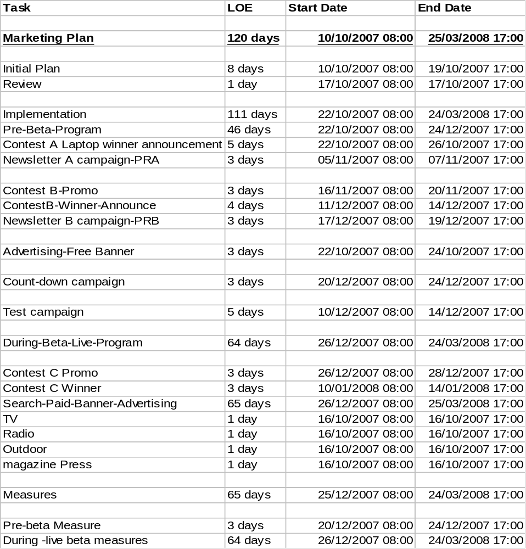

E. Measures & Metrics

The minimum measure metrics required in order to understand;

    - The Return on Investment from marketing
    - User demographical and geographical information
    - User habits and site trends
    - Supporters and Traffic Generation
    - Key word association

Initial Metrics
Activity
- # Unique users
- Visit frequency inc day and time of day of visits
- Average time spent using the platform and site
- Preferred Pages
- #registered users
- Conversion rate of subscribers to paying subscribers
- % of returning users
- Referring sites
- PR Coverage
- Brand and Key word association

Geo-socio ( registered users )

- Gender
- Age
- Status
- Geographical data

Campaigns ROI

• Campaigns analysis per lead source { Built in/Custom reports e.g Salesforce tool ?} :
- % registered users per lead source

• See reference ID(4) for a Google adwords ROI calculator

Social Media Metrics

• Users/experts conversations analysis

Additional metrics will be introduced as the beta period progresses in order to gain an increased understanding of actual site usage, user experience and site loyalty.

The additional metrics are not exhaustive at this stage and will be developed using standard reporting functionality within internet usage and internal reporting writing tools.

Advanced Metrics
Activation
• # plugins installed, #votes

Engagement
• ratio #visits/#content uploaded/broadcasted
• % active users/#total

Virality
• %growth of apps
• %growth of hotspots

Influence
• #incoming links to a profile
• ratio #top rated/#content rated
• ratio #invites/#answers

Connections
• average # friends
• average #channels & hotspots

loyalty
• surfing time
• % data posted , uploaded

Marketing Budget

Next2friends market budget will be in line with the latest projections and will be formally agreed with the CEO and COO as part of the internal project sign off process. The table below will be populated with the agreed level of spend.

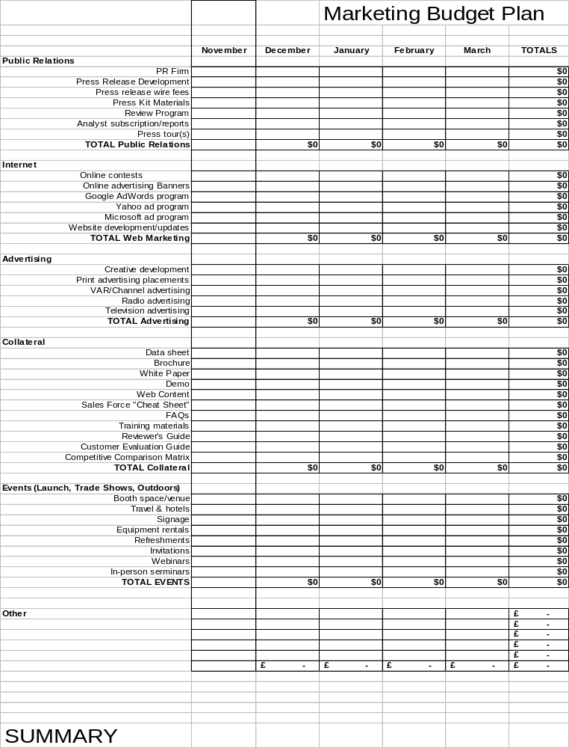

Marketing Plan Appendices

Appendix A

We will evaluate a low risk cpc |cpm adwords campaign trying to measure the best CTR and ROI during pre-beta period.Results of such a campaign will be the basement of a more consistent campaign during Live –Production period .

Prior to any action we will need to test (with exiting online tools such as Google keywords tool) keywords combination and decide which ones qualify for our cpm| cpc campaign. We may also use Google demographic capabilities for a demo target campaign .An anticipated list of keywords would be :

Keywords combinations
Free contest
iphone
Free laptop
Gadgets blogs
Mobile social networking
social networking
( some trendy mobile phone model )

See reference Id(1) for the search campaign schedule

Appendix B

- Company Launch PR Model (PR1)

[TBD]

- Funding PR Model ( PR2 )

Draft Text for Planning Purposes Only

Next2friends Secures £x.y Million in Series A Funding from [ xx]

The XX Group and Angel Investors Back pioneering Mobile Social Network That make virtual contacts real.

City, State – [Date release goes over the wire] Next2friends Ltd, the revolutionary mobile social network allowing users to stay connected to their social lives, has today announced it has raised £X.Y million in a follow-on Series A funding led by entities affiliated with the ZZZ(1). This brings total company financing to £ZZ million.

[ Quote from Capital Providers regarding Investment]
[Quote from CEO + description of the service]

[Quote, comments about such service projections ] e.g :
Josh Dhaliwal, CEO of Wireless World Forum, commented on the market opportunity by saying: "Social networks will grow by 150% in 2007. We believe the long-term continued growth lies in mobilizing those relationships. We predict 2008 to be the breakthrough year not only for mobile social networks but also for mobile social networks in Europe and North America as mass use has so far only been limited to Asia. There are 45 million mobile social network users in Asia, globally this figure will be 178 million by 2010. Mobilizing social networks is not about trying to replicate the full MySpace, Bebo or Facebook experience on mobile -- but allowing the consumer to remain connected whilst unconnected."

About Next2friends

Founded in 2007, Next2friends is the next great thing in Mobile social networking.
[TBD]

What does Next2friends for you ?

[TBD]

For further details please contact:

Europe
xxxx
zzzzzzz

Us
yyyyy
zzzzzzzz

- Soft Launch PR Model ( PR3 )

Next2friends Launches his revolutionary Mobile SN after £x.y Million in Funding

City, State – [Date release goes over the wire]
[ TBD ]

About Next2friends

Founded in 2007, Next2friends is the next great thing in Mobile social networking.
[TBD]

Appendix C

- Newsletter 1
[TBD]

- Newsletter 2
[TBD]

Appendix D

- Text for Laptop winner & 15/11/07 contest

“ Everyone at Next2Friends would like to thank you for your participation in our recent contest.
A winner has been selected, maybe its you, so come and find out by visiting www.next2friends.com.
Please remember also that our next draw will be held on the 15th of November, where we will be giving away an IPod Touch. And listen up! For even more chances to win for every email address of a friend you enter, we will place another entry in the prize draw hat for you. Your friends will also be notified so they can enter too! The more valid emails you enter, the greater the chance you or your friends have of winning.

We will regularly be running competitions for great prizes over the next few months, so for your chance to win one of these prizes and to learn more about the next2friends frenzy, check out our recently updated site or our updated blog :
www.next2friendsblog.com.

Real life, Real people, Real time.
- YouTube brings a world of video to your desktop
- FaceBook lets you and your buddies exchange and share
- MySpace hooks you up with new and exciting people
Next2Friends combines the best of all of these great services and will deliver an enriched online social experience that will rival all existing social spaces.
Hint: Think Mobile!!
Good luck & don’t miss out!

- Text for 15/12/07 contest
[TBD]

- Text to announce 15/12/07 contest winner
[TBD]

Appendix E

- New Registration Email

Each time a new registration is received the registering subscribers will receive a Thank you email containing the following text;

Dear [Enter name]

Many thanks for your registration to Next2Friends, the countdown has begun and on the 25th December, you can look forward to being one of those real privalaged users of Next2friends unique worldwide platform.

Next2Friends is set to become one of the internets largest companies because it is a significant and incredibly important evolvement of Social Networking. Until now Social Networking has been primarily internet based. Next2Friends offers a revolutionary approach by enabling Social Networking on the world’s most ubiquitous technology – the mobile device.

Real life, Real people, Real time.
- YouTube brings a world of video to your desktop
- FaceBook lets you and your buddies exchange and share
- MySpace hooks you up with new and exciting people
Next2Friends combines the best of all of these great services and will deliver an enriched online and mobile social experience that will rival all existing social spaces.

We will regularly be running competitions for great prizes over the next few months, so for your chance to win one of these prizes and to learn more about the next2friends frenzy, check out our recently updated site or our updated blog : www.next2friendsblog.com.

